Name : Comments :

Group :

**Proposal/Report : Assignment 2 (Collaborative AI)**

________________________________________________________________________

**Instructions**

Create 2 FSMs ( minimum 3 state) each with trigger conditions (no key press) and responses.

Design the FSMs to support or help each other in team play through message boarding.

Each FSM( its object) should send 1 message and respond to 1 message.

Responses can be via HUDs and other forms of notification.

**Police FSM** States

The Police are patrolling around the bank.  
 When a robber is spotted, the Police leader will order the police to advance.  
 Inside the bank, the police will take cover.  
 After taking cover, police will open fire.  
 If a police is shot, a friendly police will go to the injured police.

After reaching the police, they will drag him to cover in the back.

If the police health is less than 0, they died.

Should the police leader die, another police officer will become the leader.

Conditions

The Police are patrolling around the bank.  
 When a robber is spotted, the Police leader will order the police to advance.  
 Inside the bank, the police will take cover.  
 After taking cover, police will open fire.  
 If a police is shot, a friendly police will go to the injured police.

After reaching the police, they will drag him to cover in the back.

If the police health is less than 0, they died.

Should the police leader die, another police officer will become the leader.

Receive Message from Leader

Detect Robbers

Health Points less than amount

Distance to object

Leader dead?

State Transition Diagram

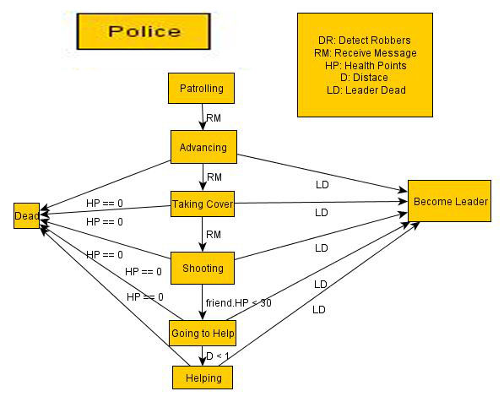

**Robber FSM** States

At the start, robbers are stealing money.

When their bags are full of money, they will move the money.  
 If the lookout sees Police coming, he will send a warning to the rest.

If the robbers received the warning, they will take cover or escape.  
 After taking cover, they will fire on the police.

If two robbers are down, an escape message is sent.

Robbers will escape if they received the message to retreat.  
 If a robbers is shot, a friendly robbers will go to the injured police.

After reaching the robbers, they will drag him to cover in the back.

If the robbers health is less than 0, they died.

Conditions

At the start, robbers are stealing money.

When their bags are full of money, they will move the money.  
 If the lookout sees Police coming, he will send a warning to the rest.

If the robbers received the warning, they will take cover or escape.  
 After taking cover, they will fire on the police.  
 If two robbers are down, an escape message is sent.

Robbers will escape if they received the message to retreat.  
 If a robbers is shot, a friendly robbers will go to the injured police.

After reaching the robbers, they will drag him to cover in the back.

If the robbers health is less than 0, they died.

State Transition Diagram

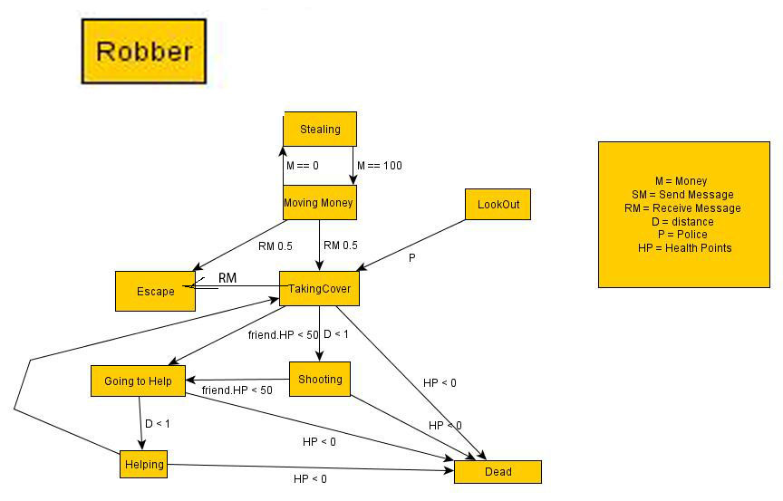

Message Board

|  |  |  |  |  |
| --- | --- | --- | --- | --- |
| **Text** | **From** | **To** | **Response** | **Remarks** |
| Move to cover! | Robber Lookout | Robber | Robbers stop stealing. Robbers move to cover, and some escape. |  |
| Run! | Robbers | Robbers | Robbers stop attacking and runs towards exit. |  |
|  |  |  |  |  |
| Get into positions | Police | Police Leader | Police stop patrolling. Police Leader issues orders. |  |
| Attack robbers! | Police Leader | Police | Police move into the bank and take cover. |  |
|  |  |  |  |  |